AZ-900 Premium Exam Pack
Microsoft Azure Fundamentals — Study, Revise, Pass
Inside this pack:
6 visual Azure architecture maps
30 exam-style practice questions with explanations
Most-confused topics • 1-day crash revision sheet
34 mobile flashcards

Exam code | AZ-900
Title | Microsoft Azure Fundamentals
Questions | ~40–60 (multiple choice & multi-response)
Time | ~45–60 minutes
Passing score | 700 / 1000
Cost | Check the Microsoft exam page for current local pricing
Prerequisites | None — foundational, no hands-on required

Prepared for Sanjeev Ranadey

Exam Blueprint — Skills Measured

Domain | Weighting
Describe cloud concepts | 25–30%
Describe Azure architecture and services | 35–40%
Describe Azure management and governance | 30–35%
Tip: AZ-900 is conceptual — you don't need to deploy anything. Focus on knowing what each service is for and when to use it, plus the cost and governance tooling.

1 · Visual Architecture Maps

Study these first — they anchor most exam questions.
1. Cloud Concepts: Service & Deployment Models
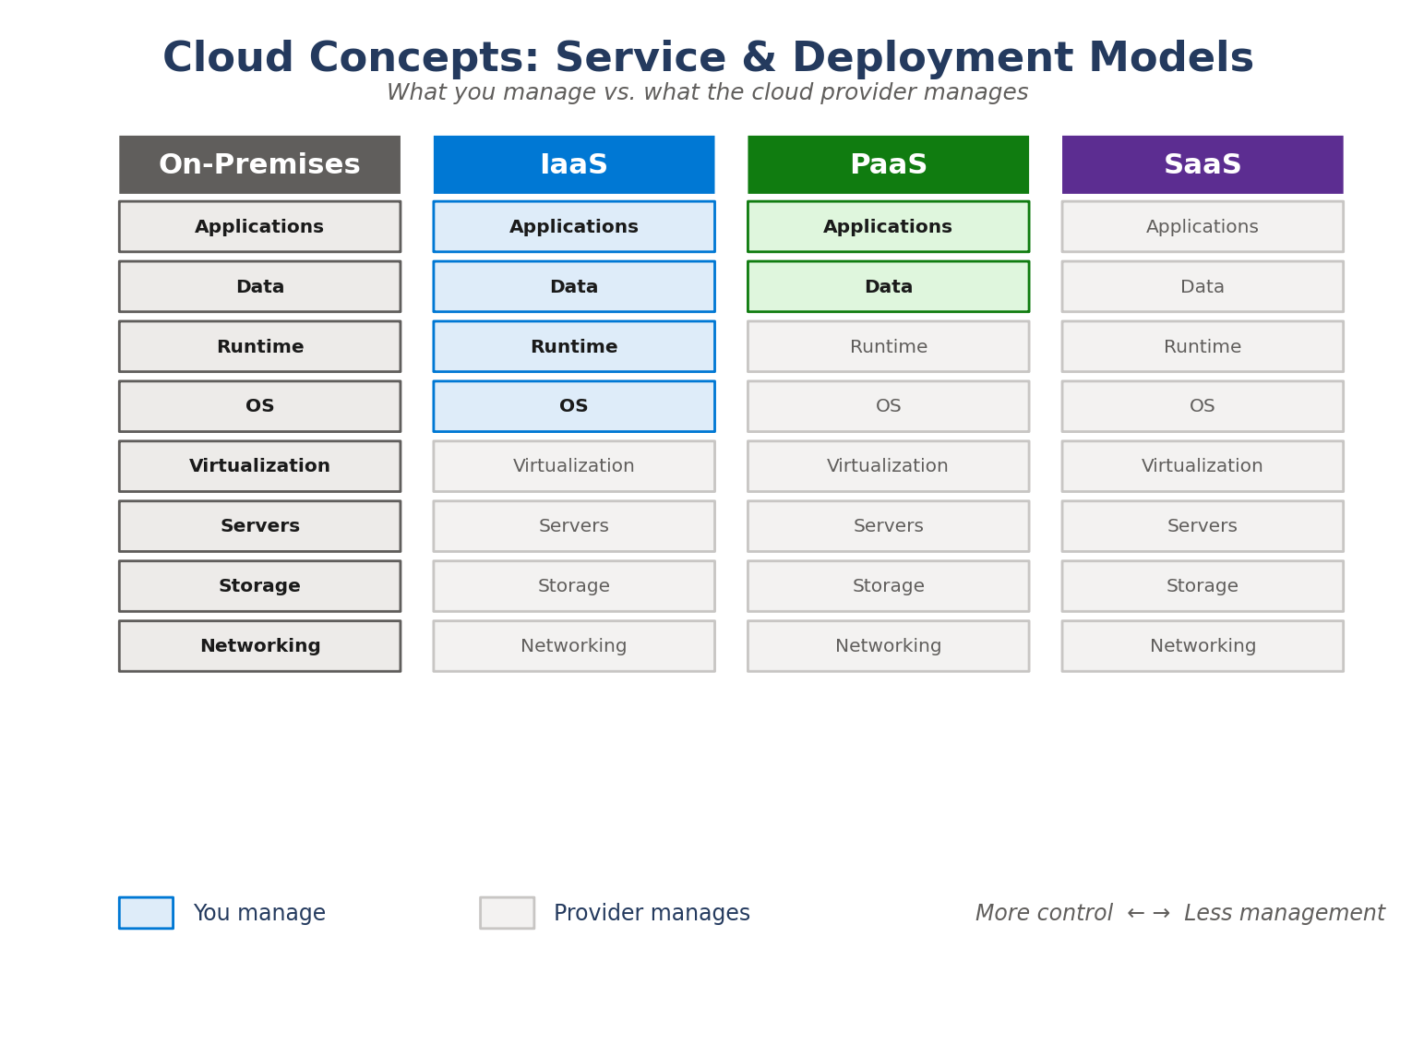
How responsibility splits between you and the provider across On-Prem, IaaS, PaaS and SaaS.
2. Shared Responsibility Model
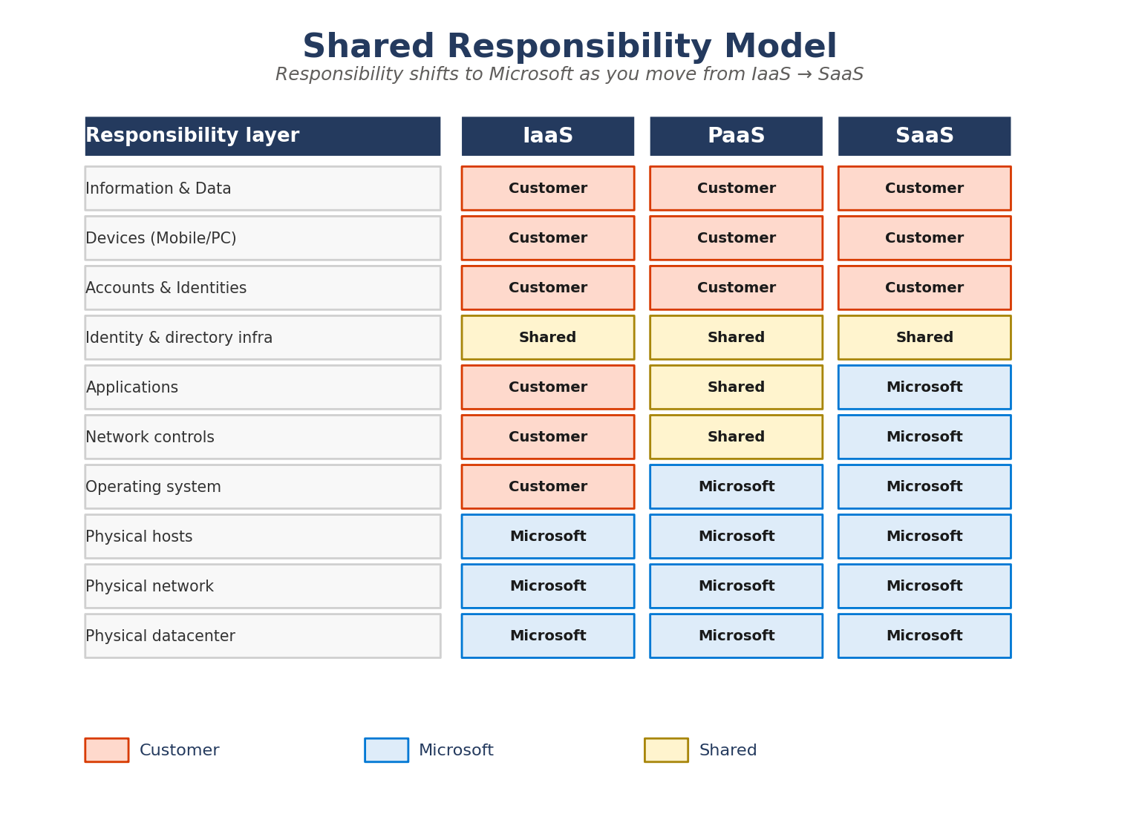
Which layers are owned by the customer, by Microsoft, or shared — across each service model.

3. Azure Global Infrastructure
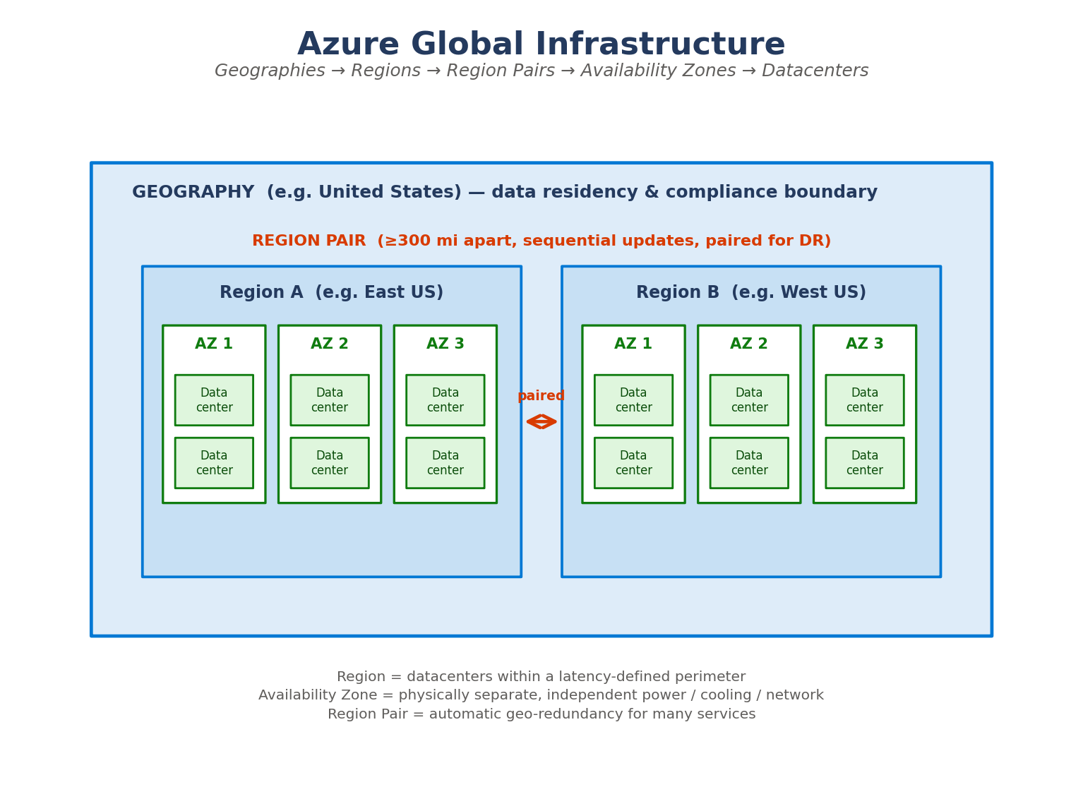
Geographies, regions, region pairs, availability zones and datacenters — and how they relate.
4. Azure Core Services
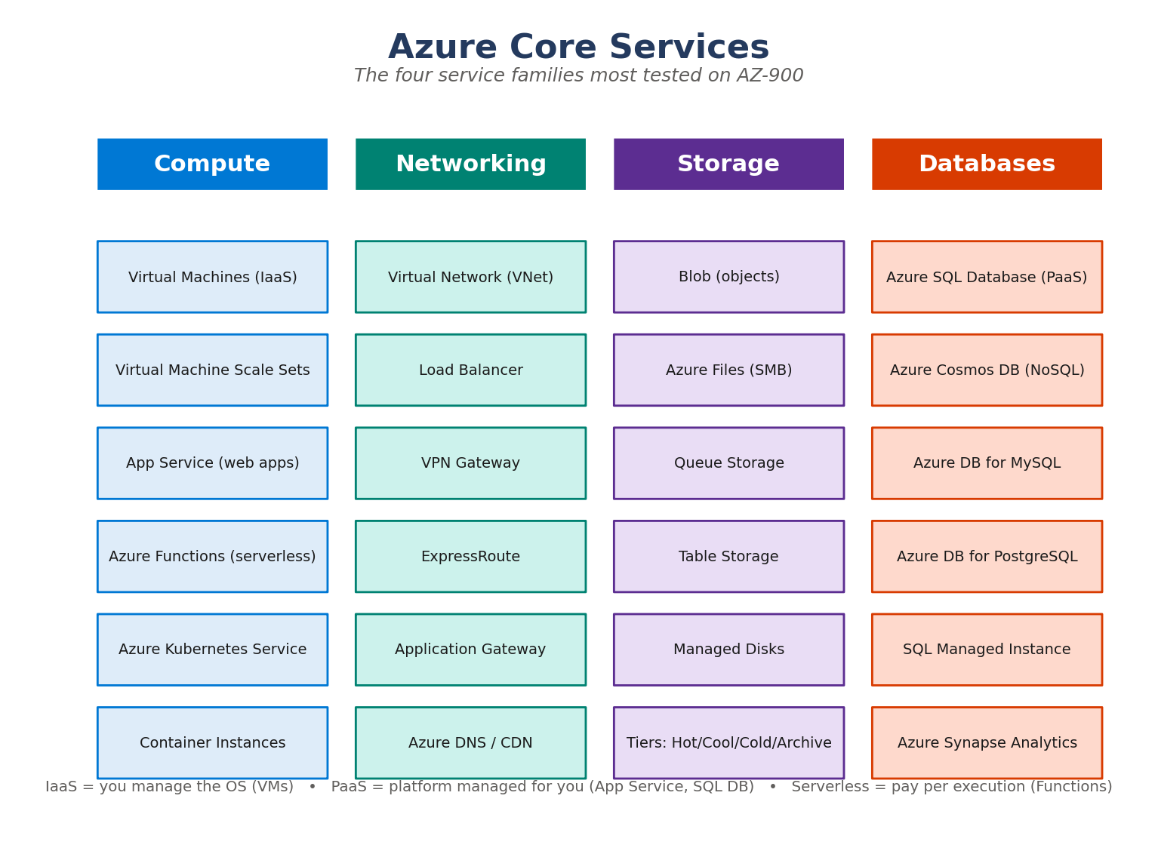
The four families: Compute, Networking, Storage and Databases.

5. Identity, Governance & Security
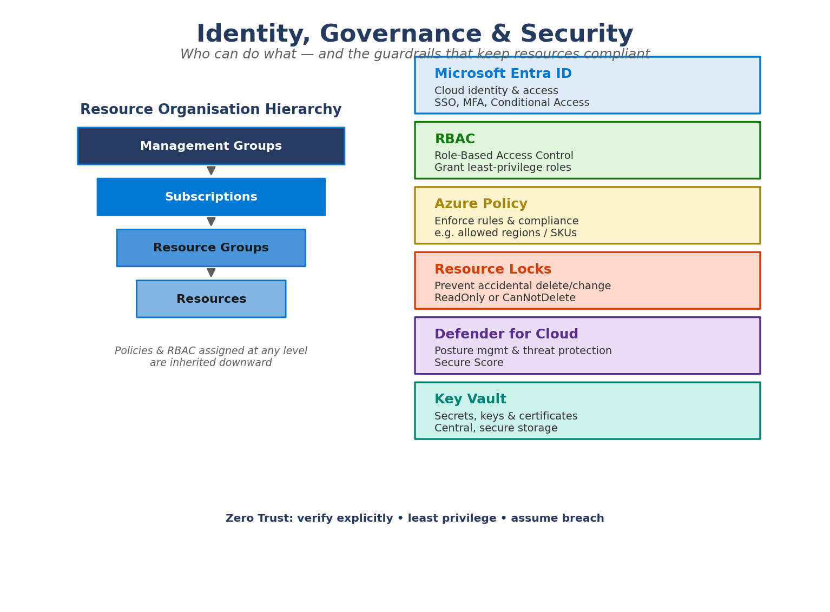
Entra ID, RBAC, Policy, Locks, Defender, Key Vault and the resource hierarchy.
6. Pricing, Cost Management & Support
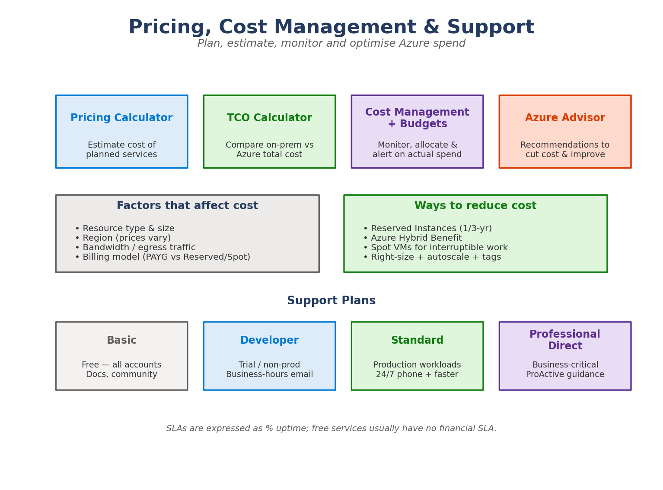
Cost tools, factors, savings levers, support plans and SLAs.

2 · Practice Questions (AZ-900 style)

30 questions. The answer key with explanations follows on the next pages — test yourself first.
Q1. Which cloud benefit means you can quickly add or remove resources to match demand? [Cloud concepts]
A. High availability
B. Elasticity
C. Disaster recovery
D. Governance
Q2. Moving from capital expenditure (CapEx) to operational expenditure (OpEx) is a key benefit of which model? [Cloud concepts]
A. On-premises datacenter
B. Consumption-based cloud
C. Private cloud only
D. Colocation hosting
Q3. In which service model are you responsible for patching the guest operating system? [Cloud concepts]
A. SaaS
B. PaaS
C. IaaS
D. FaaS
Q4. A company keeps sensitive workloads in its own datacenter but bursts to Azure at peak times. Which deployment model is this? [Cloud concepts]
A. Public cloud
B. Private cloud
C. Hybrid cloud
D. Community cloud
Q5. Which is an example of Software as a Service (SaaS)? [Cloud concepts]
A. Azure Virtual Machines
B. Azure App Service
C. Microsoft 365
D. Azure Kubernetes Service
Q6. What does 'high availability' primarily aim to achieve? [Cloud concepts]
A. Lower cost
B. Minimising downtime and keeping services running
C. Faster code deployment
D. Encrypting data at rest
Q7. Which pricing model lets you pay a reduced rate by committing to 1 or 3 years of usage? [Cloud concepts]
A. Pay-as-you-go
B. Spot pricing
C. Reserved Instances
D. Free tier
Q8. Serverless computing such as Azure Functions is best described as: [Cloud concepts]
A. You manage the physical servers
B. You pay only when your code runs, with no server management
C. A dedicated VM that never stops
D. An on-premises appliance
Q9. What is the largest unit of Azure's geographic hierarchy? [Architecture & services]
A. Region
B. Availability Zone
C. Geography
D. Datacenter
Q10. Availability Zones within a region are best described as: [Architecture & services]
A. The same datacenter split into racks
B. Physically separate locations with independent power, cooling and networking
C. Two regions paired for disaster recovery
D. Logical containers for billing
Q11. Which Azure storage service is designed for massive amounts of unstructured object data such as images and backups? [Architecture & services]
A. Azure Files
B. Azure Queue Storage
C. Azure Blob Storage
D. Azure Table Storage
Q12. You need a fully managed relational database with minimal administration. Which service? [Architecture & services]
A. Azure Cosmos DB
B. Azure SQL Database
C. Azure Virtual Machines
D. Azure Blob Storage
Q13. Which service provides a private, isolated network in Azure where you place resources like VMs? [Architecture & services]
A. Azure Virtual Network (VNet)
B. Azure DNS
C. Azure Load Balancer
D. ExpressRoute
Q14. A company wants a dedicated, private connection from its datacenter to Azure that does NOT traverse the public internet. Which service? [Architecture & services]
A. VPN Gateway
B. ExpressRoute
C. Azure Bastion
D. Application Gateway
Q15. Which compute option lets you run containers without managing the underlying Kubernetes cluster or VMs for simple scenarios? [Architecture & services]
A. Azure Kubernetes Service
B. Azure Container Instances
C. Virtual Machine Scale Sets
D. Azure Batch
Q16. Which Azure tool gives a single, cross-platform command-line experience using commands like 'az vm create'? [Architecture & services]
A. Azure PowerShell
B. Azure CLI
C. Azure Portal
D. ARM templates
Q17. What is the purpose of an Azure Resource Manager (ARM) template? [Architecture & services]
A. To monitor VM performance
B. To define infrastructure declaratively as code for repeatable deployments
C. To assign user roles
D. To estimate monthly costs
Q18. Which service automatically increases or decreases the number of identical VMs based on demand? [Architecture & services]
A. Azure App Service
B. Virtual Machine Scale Sets
C. Azure Functions
D. Azure Bastion
Q19. Azure Cosmos DB is best suited for which type of workload? [Architecture & services]
A. Highly relational reporting with complex joins
B. Globally distributed, low-latency NoSQL applications
C. Long-term archival of cold files
D. Hosting a single static website
Q20. Which service helps distribute incoming network traffic across multiple backend VMs at layer 4? [Architecture & services]
A. Azure DNS
B. Azure Load Balancer
C. Azure Firewall
D. Azure Monitor
Q21. Which storage access tier is the cheapest to store but most expensive to access, suited to rarely needed long-term data? [Architecture & services]
A. Hot
B. Cool
C. Archive
D. Premium
Q22. Which service is Azure's cloud-based identity and access management solution? [Management & governance]
A. Azure Policy
B. Microsoft Entra ID
C. Azure Monitor
D. Azure Blueprints
Q23. You want to grant a user permission to manage only virtual machines in one resource group. What should you use? [Management & governance]
A. Azure Policy
B. Role-Based Access Control (RBAC)
C. A resource lock
D. Microsoft Defender for Cloud
Q24. Which feature enforces organisational rules — for example, allowing resources only in certain regions? [Management & governance]
A. Azure Policy
B. RBAC
C. Azure Advisor
D. Resource locks
Q25. What does a 'CanNotDelete' resource lock do? [Management & governance]
A. Encrypts the resource
B. Lets users read and modify but not delete the resource
C. Prevents all access
D. Automatically backs up the resource
Q26. Which tool helps you estimate the cost of Azure services BEFORE you deploy them? [Management & governance]
A. Azure Cost Management
B. Azure Pricing Calculator
C. Azure Advisor
D. Azure Monitor
Q27. Which tool compares the total cost of running workloads on-premises versus in Azure? [Management & governance]
A. Pricing Calculator
B. Total Cost of Ownership (TCO) Calculator
C. Azure Advisor
D. Service Health
Q28. Which service provides personalised recommendations on cost, security, reliability and performance? [Management & governance]
A. Azure Advisor
B. Azure Policy
C. Azure Blueprints
D. Azure Bastion
Q29. What is the main purpose of applying tags to Azure resources? [Management & governance]
A. To encrypt them
B. To organise resources and track cost by metadata such as department or project
C. To grant access permissions
D. To increase performance
Q30. A Service Level Agreement (SLA) of 99.9% primarily expresses: [Management & governance]
A. The security score of a service
B. A formal commitment to a level of uptime/availability
C. The number of regions a service runs in
D. The cost discount for reservations
Q31. Which service alerts you to Azure outages and planned maintenance that affect your resources? [Management & governance]
A. Azure Service Health
B. Azure Policy
C. Microsoft Entra ID
D. Azure Blueprints
Q32. Management groups sit at which position relative to subscriptions? [Management & governance]
A. Below resource groups
B. Above subscriptions, to manage many at scale
C. Inside a single resource
D. They replace subscriptions

Answer Key & Explanations

Q1. B) Elasticity
Elasticity is the ability to scale resources up or down automatically to match the current workload. Scalability is the broader capacity to grow; elasticity is the dynamic, demand-driven version.
Q2. B) Consumption-based cloud
Cloud's pay-as-you-go (consumption-based) model converts large upfront CapEx into ongoing OpEx — you pay only for what you use.
Q3. C) IaaS
With IaaS (e.g. Azure VMs) you manage the OS, runtime and applications. In PaaS and SaaS the provider patches the OS for you.
Q4. C) Hybrid cloud
Hybrid cloud combines on-premises (private) infrastructure with public cloud, letting workloads move between them — 'cloud bursting' is a classic hybrid pattern.
Q5. C) Microsoft 365
Microsoft 365 is a finished application delivered over the internet — the textbook SaaS example. App Service is PaaS; VMs and AKS lean toward IaaS/PaaS.
Q6. B) Minimising downtime and keeping services running
High availability keeps applications running with minimal downtime, often using redundancy such as availability zones and load balancing.
Q7. C) Reserved Instances
Reserved Instances (reservations) offer significant discounts in exchange for a 1- or 3-year commitment to a resource.
Q8. B) You pay only when your code runs, with no server management
Serverless abstracts servers away entirely — you deploy code and pay per execution. Azure handles the underlying infrastructure and scaling.
Q9. C) Geography
A Geography is a discrete market (often a country) that contains one or more regions and preserves data residency and compliance boundaries.
Q10. B) Physically separate locations with independent power, cooling and networking
Availability Zones are physically separate datacenters inside a region, each with independent power, cooling and networking, to protect against datacenter failure.
Q11. C) Azure Blob Storage
Blob Storage is optimised for unstructured object data (text, binary, media, backups). Files = SMB shares, Queue = messaging, Table = NoSQL key/value.
Q12. B) Azure SQL Database
Azure SQL Database is a fully managed PaaS relational database. Cosmos DB is NoSQL; running SQL Server on a VM would be IaaS with more admin overhead.
Q13. A) Azure Virtual Network (VNet)
A Virtual Network (VNet) is the fundamental building block for private networking in Azure — it isolates and segments your resources.
Q14. B) ExpressRoute
ExpressRoute provides a private, dedicated connection through a connectivity provider, bypassing the public internet. A VPN Gateway uses encrypted tunnels over the internet.
Q15. B) Azure Container Instances
Azure Container Instances (ACI) runs a single container quickly without orchestration. AKS is for managed Kubernetes orchestration at scale.
Q16. B) Azure CLI
The Azure CLI uses 'az' commands and runs on Windows, macOS and Linux. Azure PowerShell uses cmdlets (Verb-Noun); the Portal is the GUI.
Q17. B) To define infrastructure declaratively as code for repeatable deployments
ARM templates are JSON files that declaratively define resources, enabling consistent, repeatable infrastructure-as-code deployments.
Q18. B) Virtual Machine Scale Sets
Virtual Machine Scale Sets let you create and manage a group of load-balanced, identical VMs that autoscale with demand.
Q19. B) Globally distributed, low-latency NoSQL applications
Cosmos DB is a globally distributed, multi-model NoSQL database offering single-digit millisecond latency and elastic scale.
Q20. B) Azure Load Balancer
Azure Load Balancer distributes inbound traffic across backend resources at the transport layer (TCP/UDP, layer 4). Application Gateway works at layer 7.
Q21. C) Archive
The Archive tier has the lowest storage cost but highest access cost and retrieval latency — ideal for data you almost never read, like compliance archives.
Q22. B) Microsoft Entra ID
Microsoft Entra ID (formerly Azure Active Directory) manages identities, authentication, SSO and MFA for cloud access.
Q23. B) Role-Based Access Control (RBAC)
RBAC assigns specific roles (e.g. Virtual Machine Contributor) at a defined scope such as a resource group, following least-privilege.
Q24. A) Azure Policy
Azure Policy evaluates resources against rules and can deny or audit non-compliant ones — e.g. restricting allowed locations or SKUs. RBAC controls *who*, Policy controls *what*.
Q25. B) Lets users read and modify but not delete the resource
A CanNotDelete lock allows reading and modifying a resource but blocks deletion. ReadOnly locks block changes and deletion.
Q26. B) Azure Pricing Calculator
The Pricing Calculator estimates the cost of planned services up front. Cost Management tracks and analyses *actual* spend after deployment.
Q27. B) Total Cost of Ownership (TCO) Calculator
The TCO Calculator estimates savings by comparing your current on-premises costs against equivalent Azure costs over time.
Q28. A) Azure Advisor
Azure Advisor analyses your environment and recommends improvements across cost, security, reliability, operational excellence and performance.
Q29. B) To organise resources and track cost by metadata such as department or project
Tags are name/value metadata that help organise resources and break down billing by department, environment or project.
Q30. B) A formal commitment to a level of uptime/availability
An SLA is a formal commitment to performance/availability (e.g. 99.9% uptime). Many free tiers carry no financial SLA.
Q31. A) Azure Service Health
Azure Service Health provides personalised alerts and guidance about service issues, planned maintenance and health advisories affecting your resources.
Q32. B) Above subscriptions, to manage many at scale
Management groups sit above subscriptions, letting you apply governance (policy, access) across many subscriptions at once. Hierarchy: Management group → Subscription → Resource group → Resource.

3 · Most Confused Topics

Scalability vs. Elasticity | Scalability is the overall capacity to grow (add resources). Elasticity is the *automatic*, demand-driven scaling up AND down in real time. Elastic = automatic + bidirectional.
High Availability vs. Disaster Recovery | High Availability keeps a service running through small failures (redundancy, zones). Disaster Recovery is the plan to recover after a major outage (failover to another region, backups).
Region Pair vs. Availability Zone | Availability Zones protect against a datacenter failure *within* a region. Region Pairs protect against a *whole-region* failure — two regions ≥300 miles apart, updated sequentially.
IaaS vs. PaaS vs. SaaS | IaaS = you manage the OS & up (VMs). PaaS = provider manages OS/runtime, you manage app & data (App Service, SQL DB). SaaS = you just use the app (Microsoft 365).
Azure Policy vs. RBAC | RBAC controls *who* can do *what* (permissions on identities). Azure Policy controls *what* resources are allowed to exist/their configuration (compliance rules). They complement each other.
VPN Gateway vs. ExpressRoute | VPN Gateway = encrypted tunnel over the *public internet*. ExpressRoute = *private*, dedicated connection via a provider that never touches the public internet (more reliable, higher bandwidth).
Pricing Calculator vs. TCO Calculator vs. Cost Management | Pricing Calculator = estimate planned Azure cost. TCO Calculator = compare on-prem vs Azure. Cost Management = monitor & control *actual* spend after deployment.
Resource Lock vs. Azure Policy | A lock prevents accidental delete/change of a specific resource (ReadOnly / CanNotDelete). Policy enforces configuration rules across many resources (e.g. allowed regions).
Management Group vs. Subscription vs. Resource Group | Management group = container for many subscriptions (org-wide governance). Subscription = billing & access boundary. Resource group = container for related resources with a shared lifecycle.
Blob vs. File vs. Disk Storage | Blob = unstructured objects (images, backups) accessed via URL/API. Azure Files = managed SMB/NFS file shares you can mount. Managed Disks = block storage attached to a VM.
Microsoft Entra ID vs. RBAC | Entra ID *authenticates* (proves who you are: SSO, MFA). RBAC *authorises* (what you're allowed to do once authenticated). Authentication first, then authorisation.
Availability Zone vs. Region vs. Geography | Geography (country/market) > contains Regions > each region contains Availability Zones > each zone has one or more datacenters. Big to small: Geography → Region → Zone → Datacenter.

4 · 1-Day Crash Revision Sheet

Everything you need in the final hours before the exam.
Cloud benefits & concepts
- CapEx (upfront) → OpEx (pay-as-you-go) is a core cloud benefit.
- Scalability = grow capacity; Elasticity = auto scale up/down with demand.
- High availability = minimal downtime via redundancy.
- Agility = deploy fast; Reliability/Predictability via the cloud's scale.
- Consumption-based pricing = pay only for what you use.
Service models
- IaaS → you manage OS, runtime, apps (Azure VMs).
- PaaS → provider manages platform; you manage app + data (App Service, SQL DB).
- SaaS → you just use it (Microsoft 365).
- Serverless (Functions) → pay per execution, no servers to manage.
Deployment models
- Public = shared Azure infrastructure.
- Private = dedicated to one org (often on-prem).
- Hybrid = mix of both; supports 'cloud bursting'.
Global infrastructure
- Geography → Region → Availability Zone → Datacenter.
- Region Pair = two regions ≥300 mi apart for DR; updated sequentially.
- Availability Zone = physically separate, independent power/cooling/network.
Core services — know one example each
- Compute: VMs, VM Scale Sets, App Service, Functions, AKS, Container Instances.
- Networking: VNet, Load Balancer, VPN Gateway, ExpressRoute, App Gateway, DNS.
- Storage: Blob (objects), Files (SMB), Queue, Table, Managed Disks. Tiers: Hot/Cool/Cold/Archive.
- Databases: Azure SQL DB (relational PaaS), Cosmos DB (global NoSQL).
Identity, governance & security
- Entra ID = identity/authentication (SSO, MFA, Conditional Access).
- RBAC = who can do what (authorisation, least privilege).
- Azure Policy = enforce rules (allowed regions/SKUs, compliance).
- Resource locks = ReadOnly or CanNotDelete to prevent accidents.
- Defender for Cloud = posture + threat protection + Secure Score.
- Hierarchy: Management group → Subscription → Resource group → Resource (inheritance flows down).
- Zero Trust: verify explicitly, least privilege, assume breach.
Cost management & tools
- Pricing Calculator = estimate planned cost.
- TCO Calculator = compare on-prem vs Azure.
- Cost Management + Budgets = track & alert on actual spend.
- Azure Advisor = recommendations (cost, security, reliability, performance).
- Cost factors: resource type/size, region, egress bandwidth, billing model.
- Save with: Reservations, Azure Hybrid Benefit, Spot VMs, right-sizing, tags.
Management tools & monitoring
- Azure Portal (GUI), Azure CLI ('az'), Azure PowerShell (cmdlets), Cloud Shell.
- ARM templates / Bicep = infrastructure as code (declarative JSON).
- Azure Monitor = metrics/logs; Service Health = outages & maintenance alerts.
- SLA = uptime commitment (e.g. 99.9%); free tiers often have no financial SLA.

5 · Flashcards

Read the question, recall the answer, then check. 34 cards.
# | Question | Answer
1 | What converts CapEx into OpEx? | The cloud's consumption-based, pay-as-you-go pricing model.
2 | Define elasticity. | Automatically scaling resources up and down to match real-time demand.
3 | IaaS — what do YOU manage? | OS, runtime and applications (e.g. Azure Virtual Machines).
4 | PaaS — what does the provider manage? | OS, runtime and infrastructure; you manage app + data.
5 | Give a SaaS example. | Microsoft 365 (a finished app delivered over the internet).
6 | What is hybrid cloud? | A mix of public cloud and private/on-prem, with workloads able to move between them.
7 | Order the global hierarchy. | Geography → Region → Availability Zone → Datacenter.
8 | What is an Availability Zone? | A physically separate datacenter within a region with independent power, cooling and networking.
9 | What is a Region Pair? | Two regions ≥300 miles apart, paired for DR and updated sequentially.
10 | Blob storage is for… | Unstructured object data (images, video, backups).
11 | Azure Files provides… | Managed SMB/NFS file shares you can mount.
12 | Which DB is global NoSQL? | Azure Cosmos DB.
13 | Which DB is managed relational PaaS? | Azure SQL Database.
14 | VPN Gateway vs ExpressRoute? | VPN = encrypted tunnel over the internet; ExpressRoute = private dedicated link, no public internet.
15 | What is a VNet? | A private, isolated network in Azure for placing resources like VMs.
16 | Serverless means… | No server management; pay per execution (e.g. Azure Functions).
17 | Microsoft Entra ID does… | Identity & access management: authentication, SSO, MFA.
18 | RBAC controls… | WHO can do WHAT — authorisation via roles at a scope (least privilege).
19 | Azure Policy controls… | WHAT resources are allowed / their configuration (compliance rules).
20 | CanNotDelete lock allows… | Reading and modifying, but NOT deleting the resource.
21 | ReadOnly lock allows… | Reading only — no changes or deletion.
22 | Pricing Calculator is for… | Estimating the cost of planned services before deployment.
23 | TCO Calculator is for… | Comparing on-premises cost vs Azure cost.
24 | Cost Management is for… | Monitoring, allocating and alerting on actual spend.
25 | Azure Advisor gives… | Recommendations across cost, security, reliability, operations, performance.
26 | What do tags do? | Add metadata to organise resources and track cost by department/project.
27 | What is an SLA? | A formal commitment to uptime/availability (e.g. 99.9%).
28 | Azure Service Health tells you… | About outages, planned maintenance and advisories affecting your resources.
29 | Resource hierarchy? | Management group → Subscription → Resource group → Resource.
30 | Three Zero Trust principles? | Verify explicitly, use least privilege, assume breach.
31 | Azure CLI vs PowerShell? | CLI uses 'az' commands (cross-platform); PowerShell uses Verb-Noun cmdlets.
32 | What is an ARM template? | A declarative JSON file defining resources for repeatable infrastructure-as-code deployments.
33 | Cheapest storage tier for rare access? | Archive tier (lowest storage cost, highest retrieval cost/latency).
34 | Which compute autoscales identical VMs? | Virtual Machine Scale Sets.

